* Grant Permissions to Integration Services Service

<https://msdn.microsoft.com/en-us/library/hh213130(SQL.110).aspx>

version is SSIS 12.0 (2014) cant open it in SSMS 2016. Need to open it in SSMS 2014

Connect to SQL server Database engine🡪 Create SSIS Catalogs (SSISDB)

SSIS catalog passworkd Monday17!&

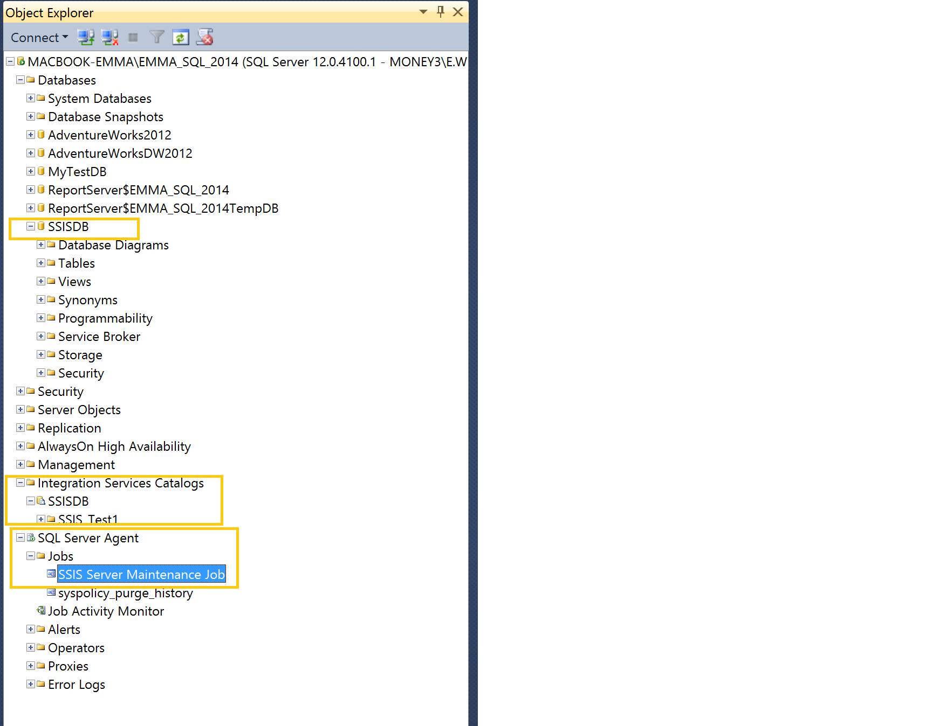

Deploy SSIS package from visual studio (Project🡪deploy). You will be able to see above highlighted items created in SSMS

Execute package in SSMS

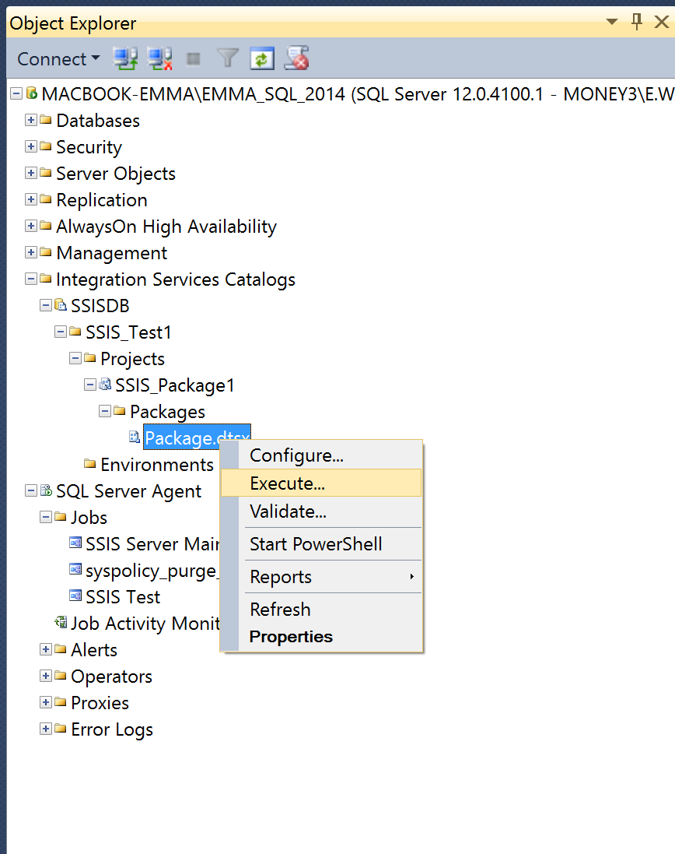

* Config SSIS to show below

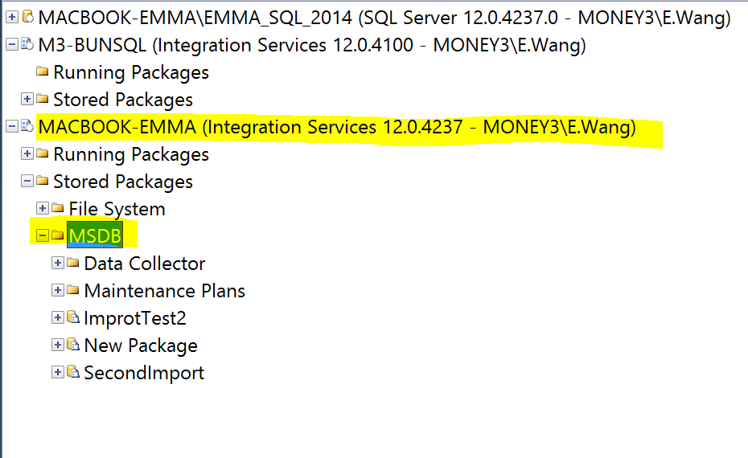

Location of the ini file

